 | 12.3.1 Editors - Geometry Nodes Editor - Sidebar - Group tab
Table of content
Group tab - Introduction 3
Group Properties Panel 3
Name 3
Description 3
Color Tag 3
Node Width 3
Group Sockets Panel 3
Group Socket List 3
List 4
Name 4
New Item 4
Input 4
Output 4
Panel 4
Duplicate Item 4
Remove Item 4
Move Item Up/Down 4
Type 4
Type Float 5
Description 5
Subtype 5
Default 5
Min 5
Max 5
Optional label 5
Hide Value 5
Hide in Modifier 5
Type Integer 5
Description 5
Subtype 6
Default 6
Min 6
Max 6
Optional label 6
Hide Value 6
Hide in Modifier 6
Type Boolean 6
Description 6
Default 6
Optional Label 6
Hide Value 6
Hide in Modifier 6
Type Vector 7
Description 7
Subtype 7
Dimensions 7
Default 7
Min / Max 7
Optional Label 7
Hide Value 7
Hide in Modifier 7
Type Color 7
Description 7
Default 8
Optional Label 8
Hide Value 8
Hide in Modifier 8
Type Menu 8
Description 8
Default 8
Expanded 8
Optional Label 8
Hide Value 8
Hide in Modifier 8
Type Shader 8
Description 8
Optional Label 8
Hide Value 9
Hide in Modifier 9
Type Bundle 9
Description 9
Optional Label 9
Hide Value 9
Hide in Modifier 9
Type Closure 9
Description 9
Optional Label 9
Hide Value 9
Hide in Modifier 9
Animation Panel 9

Group tab - Introduction
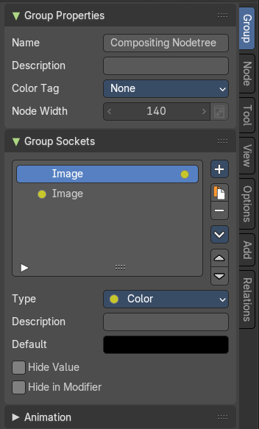
The Geometry Node sidebar Group tab at the right side contains options and settings for node groups nodes and socket input and output properties.

Group Properties Panel

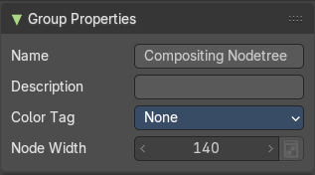
Name
Change the name of the current node group. Type in a new name and hit enter.

Description
Change the description of the current node group. Type in a new name and hit enter.

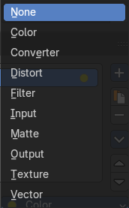
Color Tag
Changes the header color of the current node group.

Node Width
The default width of the node.

Group Sockets Panel

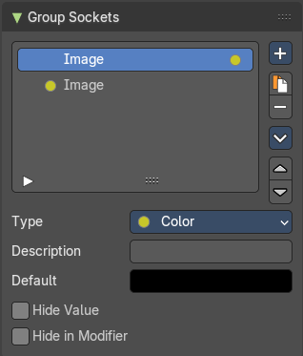
Manage the input and output properties of the Group Input and Output nodes.
More than one input and output slot can be useful when you want to modify the geometry in the node group in more than one way.

Group Socket List
List of available input and output sockets.
Note: The list can be sorted by dragging the items around.

List
The list of input and output sockets.

Name
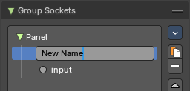
Change the name of the current selected input socket by double clicking on the socket in the list. Type in a new name and hit enter.

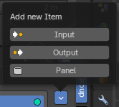
New Item
Adds a new input sockets to the list.

Input
Adds a new input sockets to the list.

Output
Adds a new output socket to the list.

Panel
Adds a new panel socket to the list.

Duplicate Item
Duplicates the active socket.

Remove Item
Removes the selected input socket from the list.

Move Item Up/Down
Moves the active item to the specified direction. You can move the active item up or down the list.
Note: You can also alternatively drag and drop the active item to re-order.

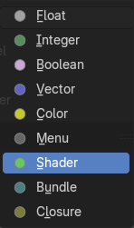
Type
What kind of node group input or output type it is. To know more about the properties of the socket types, refer to the next section.

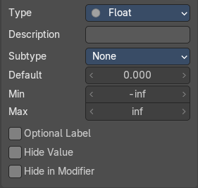
Type Float

Description
Add a tooltip to the socket description.

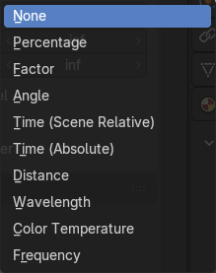
Subtype
Subtype of the default value.

Default
The default value for the socket.

Min
The minimum value for the socket.
Note: This is only available for vector and float types.

Max
The maximum value for the socket.
Note: This is only available for vector and float types.

Optional label
Hide the label if not needed.

Hide Value
Hide the input value even when the socket is not connected.

Hide in Modifier
Don’t show the value in the geometry nodes modifier interface.

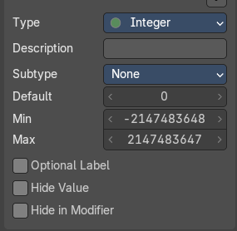
Type Integer

Description
Add a tooltip to the socket description.

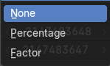
Subtype
Subtype of the default value.

Default
The default value for the socket.

Min
The minimum value for the socket.
Note: This is only available for vector and float types.

Max
The maximum value for the socket.
Note: This is only available for vector and float types.

Optional label
Hide the label if not needed.

Hide Value
Hide the input value even when the socket is not connected.

Hide in Modifier
Don’t show the value in the geometry nodes modifier interface.

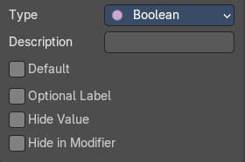
Type Boolean

Description
Add a tooltip to the socket description.

Default
The default value for the socket.

Optional Label
Make the label optional. This may resul tin the label being skipped in some cases.

Hide Value
Hide the input value even when the socket is not connected.

Hide in Modifier
Don’t show the value in the geometry nodes modifier interface.

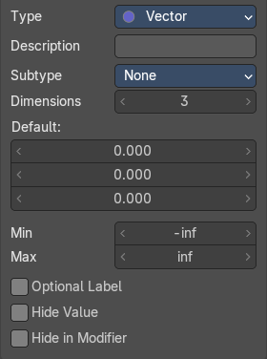
Type Vector

Description
Add a tooltip to the socket description.

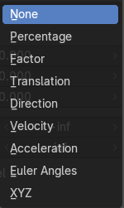
Subtype
What special math operation is required. The subtype menu allows you to define the socket type sliders and read-out.

Dimensions
How much dimensions to calculate.

Default
The default vector. It changes, dependant of what dimensions you use.

Min / Max
Minimum value and maximum value.

Optional Label
Make the label optional. This may resul tin the label being skipped in some cases.

Hide Value
Hide the input value even when the socket is not connected.

Hide in Modifier
Don’t show the value in the geometry nodes modifier interface.

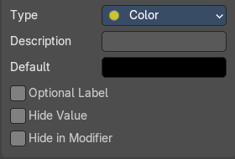
Type Color

Description
Add a tooltip to the socket description.

Default
The default color for the socket.

Optional Label
Make the label optional. This may resul tin the label being skipped in some cases.

Hide Value
Hide the input value even when the socket is not connected.

Hide in Modifier
Don’t show the value in the geometry nodes modifier interface.

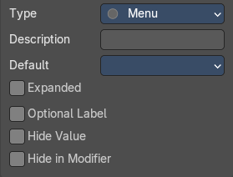
Type Menu

Description
Add a tooltip to the socket description.

Default
The default menu.

Expanded
Draw the menu socket as an expanded drop down menu.

Optional Label
Make the label optional. This may resul tin the label being skipped in some cases.

Hide Value
Hide the input value even when the socket is not connected.

Hide in Modifier
Don’t show the value in the geometry nodes modifier interface.

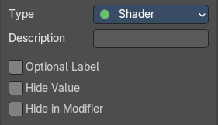
Type Shader

Description
Add a tooltip to the socket description.

Optional Label
Make the label optional. This may resul tin the label being skipped in some cases.

Hide Value
Hide the input value even when the socket is not connected.

Hide in Modifier
Don’t show the value in the geometry nodes modifier interface.

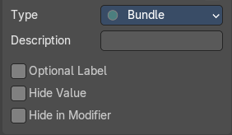
Type Bundle

Description
Add a tooltip to the socket description.

Optional Label
Make the label optional. This may resul tin the label being skipped in some cases.

Hide Value
Hide the input value even when the socket is not connected.

Hide in Modifier
Don’t show the value in the geometry nodes modifier interface.

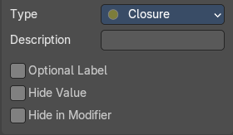
Type Closure

Description
Add a tooltip to the socket description.

Optional Label
Make the label optional. This may resul tin the label being skipped in some cases.

Hide Value
Hide the input value even when the socket is not connected.

Hide in Modifier
Don’t show the value in the geometry nodes modifier interface.

Animation Panel

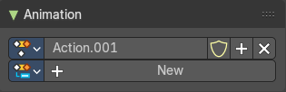
Allows you to add FCurvces for animation.
TODO

